**Appendices N**

**Observer Pattern**

To implement the observer design pattern, there was a number of steps I had to take which are documented below.



Fig x – Extract from ClientImpl, class header

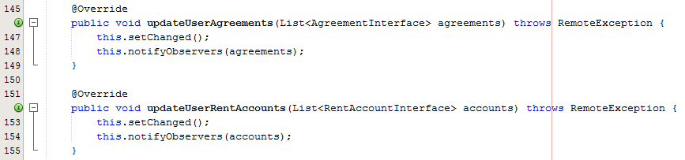

Fig x – Extract from ClientImpl class, updateUserAgreements() - updateUserRentAccounts()

As you can see from fig x and fig x, to do this I first had to make the ClientImpl class extend Observable, which meant that I had to create a method which notifies any observers when there is a change.

The methods that notify the Observers (GUI) when any changes to either agreements or rent accounts are updateUserAgreements() and updateUserRentAccounts() and both of these methods invoke two methods inherited from the Observable class, setChanged() and notifyObservers() which will notify the list of observers, that there has been a change to the object being observed (ClientImpl), and then passes the updated object as a parameter of the notifyObservers() method to the observers (GUI).

Now I have to amend the home screen, which is the GUI that will be the observer, and need to update whenever the observable notifies of any state change.



Fig x – Extract from HomeForm class (GUI), class header

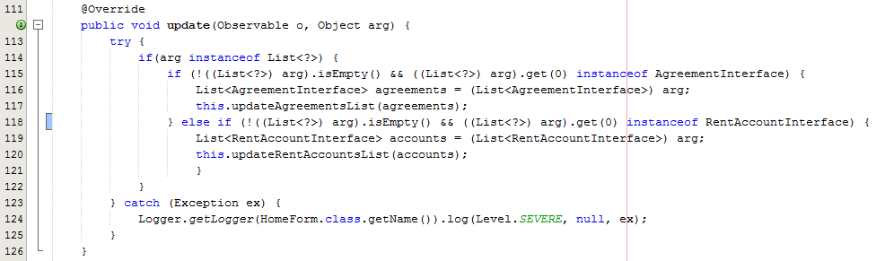

Fig x – Extract from HomeForm class (GUI), update()

As you can see from fig x and fig x, the HomeForm class implements Observer, which also means as it is a GUI, it is able to still extend JFrame, but also means that it then needs to provide an implementation for the update method. Which as explained before, will be invoked by the Observable class, when the Observer invokes setChanged() and then notifyObservers(). As you can see from fig x, the updated object is passed as a parameter. However, because it is passed as an Object I need to check if the object is an instance of the required object, and because the object passed should be a list, I first need to check to see if the Object is instance of List. But because of Type Erasure the compiler at run time does not know the type of object within a list, so I am unable to test if the list has the correct type of elements without actually obtaining an element from the list and checking the elements type.

So if the object is of type List, I then need to check if the list is empty and if not then actually get an element out of the list and test the type of the object is either instance of Agreement or instance of Rent Account.

I then invoke an update method which will amend the GUI display to reflect the change that has occurred to the Observable object.

The last part of the implementation of the Observable pattern (although it is actually now fully implemented), is that the controller must invoke ClientImpl.updateAgreements() or ClientImpl.updateRentAccounts() and again this is one of the only implementations of the push data exchange model, because the server is actually pushing a change to the client, instead of the client pulling “requesting” data from the server.

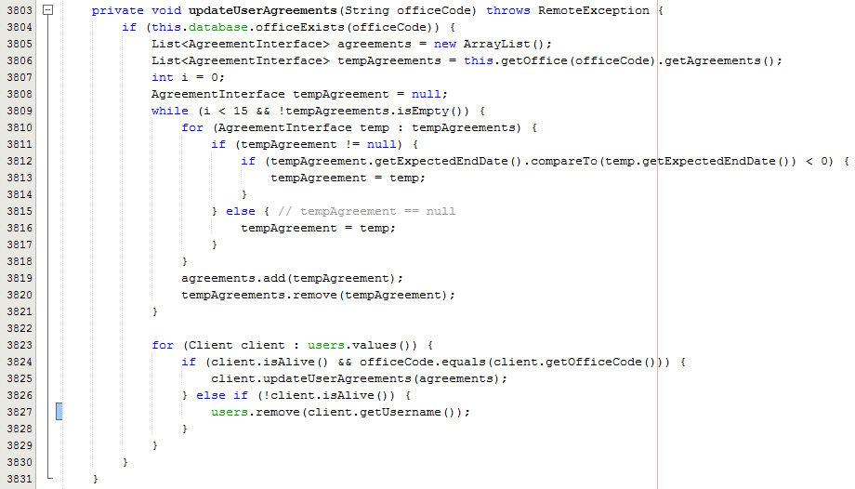

Fig x – Extract from ServerImpl class updateUserAgreements()

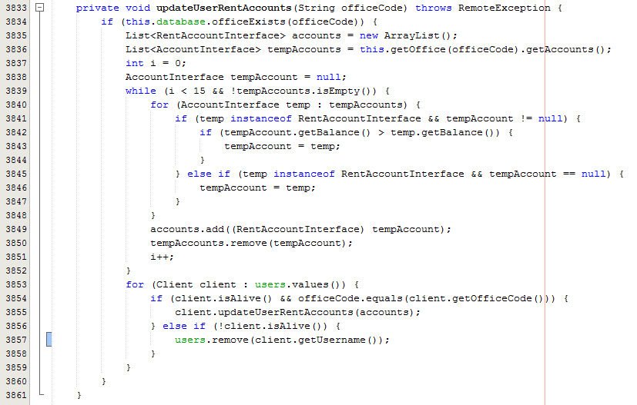

Fig x – Extract from ServerImpl class updateUserRentAccounts()

As you can see from fig x and fig x, each of these methods prepare the wist which will be the updated list (object to be passed via the notifyObservers method from ClientImpl class) after any changes have occurred. Once the list is created and all required elements have been added to the list, I then go through a list of clients checking to see if client is still alive, and if so if the client needs to receive the update (only send out update to clients of that office), and if the client is then I invoke Client.updateUserRentAccounts() or Client.updateUserAgreements(), and pass the updated list as a parameter to the method.

This then makes the Observable object the ClientImpl invoke the setChanged() and notifyObservers methods discussed earlier, which invokes the Observer objects update method. The observer pattern then allows the system for ‘MSc Properties’ to ensure that the clients home form is always updated, but also does not send unnecessary updates to all clients that don’t need the update.